**Lab Task – 1**

**1. Write a program in assembly language to print “Hello World”.**

org 100h

jmp start

msg: db "Hello, World!", 0Dh, 0Ah, 24h

start: mov dx, msg

mov ah, 09h

int 21h

mov ah, 0

int 16h

ret

**Output:**

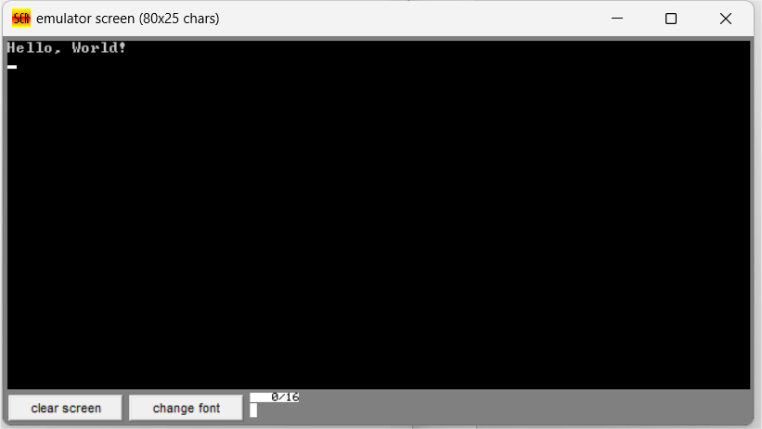

**2. Write an assembly language program to print your name.**

org 100h

jmp start

msg: db "Lingam Chaitali", 0Dh, 0Ah, 24h

start: mov dx, msg

mov ah, 09h

int 21h

mov ah, 0

int 16h

ret

**Output:**

